Vocational school for computer programming and innovation



Swimming pool

|  |
| --- |
| Georgi Stoychev Koradov |
| Ivelin Petrov Bachvarov |
| Georgi Stefanov Kalchev |
| |  | | --- | | Mentor- Petar Georgiev |   Kiril Hristov Dimov |
|  |

**Content**

1 Short description of the project and objectives 3

2 Diagram describing menus 3

3 Description of the used functions 4

Table of figures

Figure 1 3

List with tables

Table 1 4

# Short description of the project and objectives

Our project is a computer program written on Visual Studio 2019, which has features designed to facilitate the work of people working at the swimming pools especially water parks. It has features for adding, displaying, editing, deleting and showing clients by criteria as well as the income for the week. In the future, this code may be associated with some system that scans the person and finds only this data that needs to be recorded. Our goals are to optimize our code so that it can be usable and eventually implemented somewhere.

# Diagram describing menus

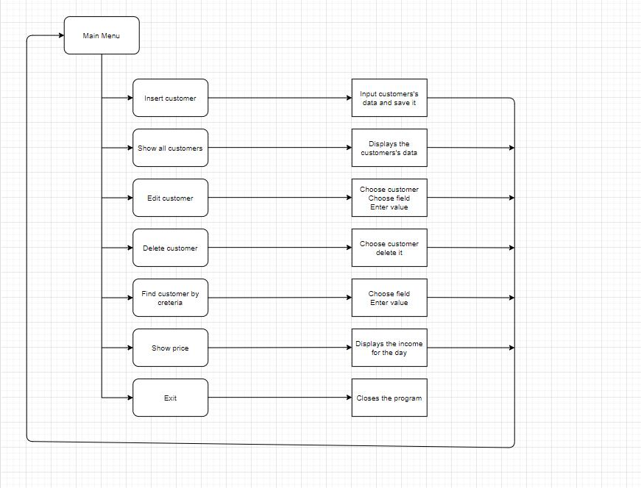

Figure 1

# 

|  |  |  |  |
| --- | --- | --- | --- |
| Name | Arguments | Description | Returned value |
| insertCustomer | SWIMMINGPOOL* customers- a directory that points to the elements of an array of type structures and we use ‘*’ so we can work with the real values;  int& customercount- serves as a counter | Serves for entering the data. | None |
| showCustomer | SWIMMINGPOOL customer- an array that is type structure and it is used to display all stored elements in the structure | Serves for displaying the information on the screen. | Customer information |
| getCustomerIndexById | Int &customercount- serves as a counter  int id | Serves to find the index of a client according to his id. | Return the index of the customer. |
| editCusotmer | SWIMMINGPOOL* customers- a directory that points to the elements of an array of type structures  int& customercount- serves as a counter  int& maxId- | For editing part from the customers data. | None |
| deleteCustomer | SWIMMINGPOOL* customers- a directory that points to the elements of an array of type structures  int& customercount- serves as a counter  int id- to enter the exact index on which we want to delete customer information | To delete customer data. | None |
| findCusotmersByTime | SWIMMINGPOOL* customers- a directory that points to the elements of an array of type structures  int& customercount- serves as a counter | To find customers based on his duration of stay. | None |
| customersMenu | SWIMMINGPOOL* customers- a directory that points to the elements of an array of type structures  int& customercount- serves as a counter  int& maxId- | Menu with all possible choices. | The menu of the function |

# Description of the used functions

Table 1